### A PROJECT REPORT

### ON

**Website to Android App convert using Android Studio**

**For the partial fulfillment for the award of the degree of**

**BACHELOR OF TECHNOLOGY**

#### In

**COMPUTER SCIENCE AND ENGINEERING**

**Submitted By**

**Pranjal Dubey (2001921520038)**

**Praveen Kumar (2001921520040)**

**Kartik Singh (2005111520007)**

**Under the Supervision of**

**Ms. Deepshi Tyagi**





**G.L. BAJAJ INSTITUTE OF TECHNOLOGY & MANAGEMENT, GREATER NOIDA**

**Affiliated to**

**DR. APJ ABDUL KALAM TECHNICAL UNIVERSITY,**

**LUCKNOW**

**2021-22**

**Declaration**

We hereby declare that the project work presented in this report entitled **“Website to Android App convert using Android Studio”*,*** in partial fulfillment of the requirement for the award of the degree of Bachelor of Technology in Computer Science & Engineering, submitted to A.P.J. Abdul Kalam Technical University, Lucknow, is based on my own work carried out at Department of Computer Science & Engineering, G.L. Bajaj Institute of Technology & Management, Greater Noida. The work contained in the report is original and project work reported in this report has not been submitted by me/us for award of any other degree or diploma.

|  |  |  |  |  |  |
| --- | --- | --- | --- | --- | --- |
| Signature: |  |  | Signature: |  |  |
| Name: | Pranjal Dubey |  | Name: | Praveen Kumar |  |
| Roll No: | 2001921520038 |  | Roll No: | 2001921520040 |  |
|  |  |  |  |  |  |
|  |  |  |  |  |  |
| Signature: |  |  | Signature: |  |  |
| Name: | Kartik Singh |  | Name: |  |  |
| Roll No: | 2005111520007 |  | Roll No: |  |  |

Date:

Place: Greater Noida

## Certificate

This is to certify that the Project report entitled **““Website to android app convert using android studio” done by Pranjal Dubey (2001921520038), Praveen Kumar (2001921520040) and Kartik Singh (2005111520007)** is an original work carried out by them in Department of Computer Science & Engineering, G.L Bajaj Institute of Technology & Management, Greater Noida under my guidance. The matter embodied in this project work has not been submitted earlier for the award of any degree or diploma to the best of my knowledge and belief.

Date: 05/01/2022

##### Ms. Deepshi Tyagi Dr. Sanjeev Kumar Pippal

**Signature of the Supervisor Head of the Department**

**Acknowledgement**

The merciful guidance bestowed to us by the almighty made us stick out this project to a successful end. We humbly pray with sincere heart for his guidance to continue forever.

We pay thanks to our project guide Ms**. Deepshi Tyagi** who has given guidance and light to us during this project. Her versatile knowledge has cased us in the critical times during the span of this project.

We pay special thanks to our Head of Department Dr. Sanjeev Kumar Pippal who has been always present as a support and help us in all possible way during this project.

We also take this opportunity to express our gratitude to all those people who have been directly and indirectly with us during the completion of the project.

We want to thanks our friends who have always encouraged us during this project.

At the last but not least thanks to all the faculty of CSE department who provided valuable suggestions during the period of project.

## Abstract

**According to Ericsson forecasts, global mobile traffic has been continuously growing and has increased tenfold since 2016. And smartphones generate 95% of that traffic.**

**From selling products and social networking to managing your bank account and reading blogs, literally any operation you perform on your smartphone is processed by an app. According to TechCrunch (App Annie), users spend 4.2hrs per day, on average, in mobile applications.**

**In this project we will learn how we can convert any website to an android application.**

**we will use android studio thorough our project to complete our app development and after completion of project we can convert any web page and website to real time android application along with it our project comes with full video support and it runs videos smoothly.**

**We have also added No Internet detection to our Project so that it can detect whether you are connected to internet or not.**

#### TABLE OF CONTENT

Declaration.................................................................................................. (ii)

Certificate ................................................................................................................. (iii)

Acknowledgement .......................................................................................................... (iv)

Abstract ................................................................................................................. (v)

Table of Content................................................................................................................. (vi)

List of Figures ………………………………………………………………………… (viii)

|  |  |  |
| --- | --- | --- |
| **Chapter 1.** | **Introduction ..........................................................................................** | Pg. No. |
| 1.1 | Problem Definition….............................................................................. | 10 |
| 1.2 | Project Overview / Specifications........................................................... | 10 |
| 1.3 |  |  |
| **Chapter 2.** | **Existing System ........................................................** | Pg.No |
| 2.1 | Introduction ………………………………………………………….. | 11 |
| 2.2 | Existing System.................................................................................... | 11 |
| 2.3 |  |  |
| **Chapter 3.** | **Result and future scope………………………….…….** | Pg.No |
| 3.1 | Result | 12 |
| 3.2 | Future scope. | 12 |

**LIST OF FIGURES**

|  |  |  |
| --- | --- | --- |
|  |  | **Page No.** |
| **Figure 1.1** |  | Pg.No |
| **Figure 1.2** |  | Pg.No |
| **Figure 2.1** |  | Pg.No |
|  |  |  |
|  |  |  |
|  |  |  |
|  |  |  |
|  |  |  |
|  |  |  |
|  |  |  |
|  |  |  |
|  |  |  |
|  |  |  |
|  |  |  |
|  |  |  |
|  |  |  |
|  |  |  |
|  |  |  |
|  |  |  |
|  |  |  |

Figure 1.1

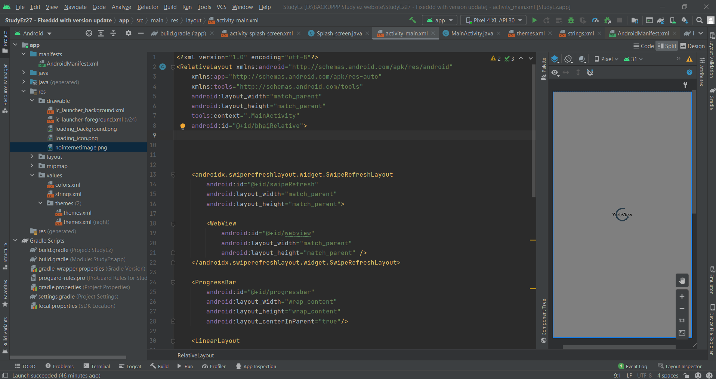

Figure 1.2

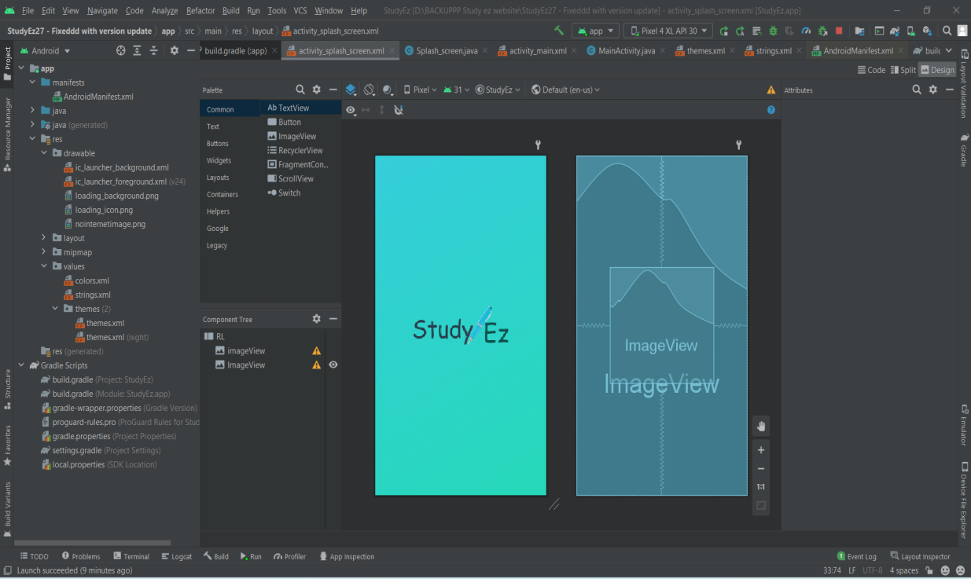

Figure 2.1

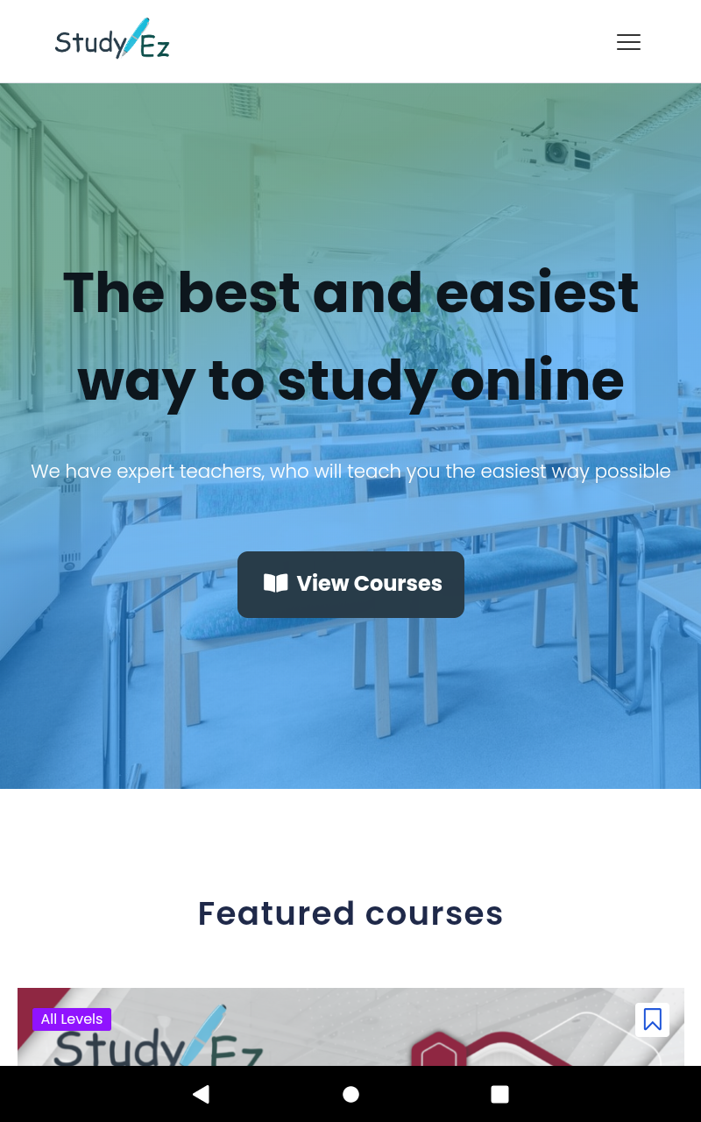

# Chapter 1

## Introduction

**Introduced first by Google in 2015, Progressive Web Apps became a new promising technology allowing you to extend the functionality of websites and make them more reliable, fast and engaging, i.e. get all the advantages of native apps.**

**Technically, progressive web apps looked like sites, but allowed to use the browser as a virtual machine launching the site logic locally and getting only the actual/updated data via the web.**

**It is thanks to this technology you can now see push notifications from your favorite news website and access your web services to get the tickets or check the details on your delivery order even when you’re offline.**

**In 2021, you’re probably using progressive web apps everyday without knowing that. Spotify, Pinterest, Uber, 2048 Game, Flipboard and Starbucks are all examples of PWA. As a website application development company, today we’re mostly asked to build PWAs.**

**However, PWAs still can’t do everything that native apps can. They’re poorly compatible with old devices, they’re not very battery efficient, and you may bump into system limitations put on browsers they will force you limit your service’s functionality or performance.**

# Chapter 2

## EXISTING SYSTEM AND CONCLUSION

**In particular, if you are testing the solution on Xamarin for Android, you will need the help of the Visual Studio Android emulator. In order to get started, simply select your project with the extension ‘.Android’ or ‘.Droid’, designate the device for emulation, and press the start button. Now the testing procedure has begun! We must note that emulators are resource-hungry, thus they would operate quite slowly on low-spec computers.**

**Further 2 Important Points are :**

**1. Keep in Mind the Nuances of the Platform-specific UI Design Guidelines**

**As you may already know, the two most popular mobile platforms – iOS and Android – have some basic guidelines about the interface design that are applied to mobile applications placed in their official marketplaces. Therefore, when creating a design for your mobile application, you will need to take into account the principles upon which Flat Design (in iOS) and Material Design (in Android) are based.**

**2. Adapt the Interface to the Display Format of Mobile Devices**

**It is important to remember that the quality criteria, used in the development of native and native-like mobile applications, is very specific. As a rule, mobile apps are limited to the size of displays. The important characteristics that you will need to keep in mind during development are also the power consumption evaluation (the mobile application should expend the battery of the user device sparingly), staying responsive even on weaker hardware, adaptability to efficient operation within the selected OS (in particular, it should not conflict with other processes running on the user device), as well as the quality of the interaction with the specific functionality of the smartphone or tablet (for example, touchscreen, contact book, camera, GPS sensors etc.**

# Chapter 3

## RESULT AND FUTURE SCOPE

**We have successfully made our project and as shown in figures and live demonstration it is running and converting ant web page into an android application**

**Talking about future scopes of our projects we have a lot of things in mind including adding direct install button to give user a better experience to directly add web-apps to their device .**

**Features like autoplay of videos and better touch response and animations will be added too in future,**

**As there are a lot of mobile phone users we think our project is of great use!**

# References

Appendix A: Glossary

<Define all the terms necessary to properly interpret the SRS, including acronyms and abbreviations. You may wish to build a separate glossary that spans multiple projects or the entire organization, and just include terms specific to a single project in each SRS.>